**AB Flips Projects Showcase**

**Nucamp Bootstrap Portfolio Project**

**Bernice Carbaugh**

**1. Introduction**

* My sister and I have a home-flipping side business and I’m building a website to showcase our past projects and provide more information about us. For the purpose of this Bootstrap course, I’m just going to shoot for a bare bones site, with a home page, a project pages with maybe 3-4 projects, and an about us page.

**2. User Interface Design and Prototype**

* For the home page, there should be brief introduction section and a project navigation section where you can click and go to the project page for that home, and some quotes or interest element. It would be great to have a map with clickable pin for that home.
* For the project pages, which will be the same for each project, there will be a summary section describing the project, and a photo carousel with accompanying descriptions, as shown in the wireframe below. 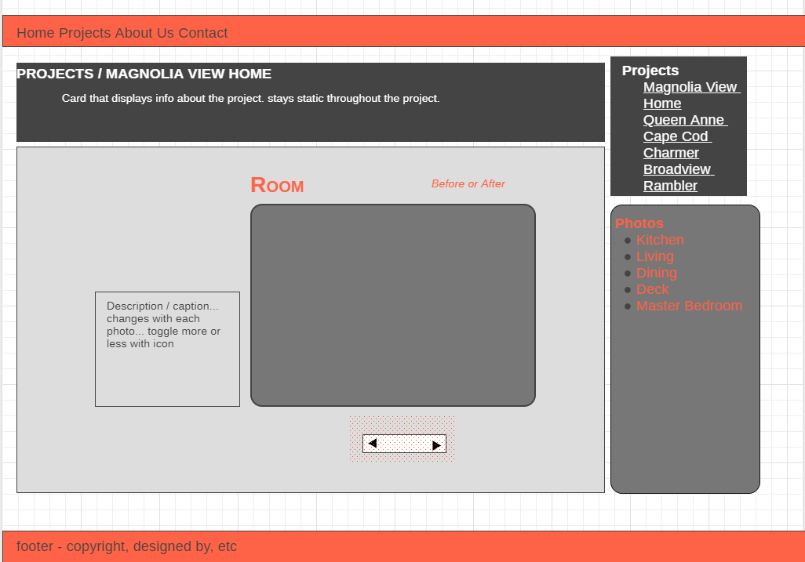

**3. Navigation Structure**

* The heart of the site will be the project pages and the galleries for each page. Users should be able to navigate between projects and also the photos for each project.
* The user should also always know where in the “slideshow” they are, and how to go backwards, forwards, skip to a different room, etc.
* Generally, the gallery will show one photo at a time, but it would be great to have a way show before and after side-by-side. Maybe certain after shots, you can hover or click and a “ghost” like before picture shows to the side.

**4. References**

* https://www.remodeltour.com/2018-homes
* https://sustainableconnections.org/nw-green-home-tour-bellingham-sites-2019/
* http://tenhulzen.com/portfolio/